The Medical Landscape in Sub-Saharan Africa: Evidence from SDI Medical Vignettes in 11 Countries

list all the authors

April 30, 2021

# Abstract

Primary care is at the center of improving population access to healthcare and yet there are limited studies on medical provider demographics in Sub-Saharan Africa. The World Bank’s Service Indicators (SDI) surveys have attempted to fill this gap. Using SDI surveys of 9,712 health facilities and 87,153 healthcare providers in 11 Sub-Saharan countries, we investigate the demographic makeup of healthcare providers to better understand the average citizen’s experience of primary care in Sub-Saharan Africa. The results indicate that majority of the health facilities across these 11 countries are health posts that are predominately located in rural areas. Furthermore, female providers comprise a majority of the staff regardless of health facility type. In terms of provider cadre, patients are most likely to be taken care of by a nurse or paramedical staff member as these providers are the most present at health facilities daily. Moreover, rural health facilities have a lower share of medical officers when compared to their urban counterparts. The SDI surveys offer an opportunity to examine carefully who are the healthcare providers that staff the health facilities in these 11 countries, which is an essential first step towards primary care reform.

# Introduction

The Service Delivery Indicators (SDI) surveys were developed to directly respond to the need for accountability in social sector service delivery. The SDI initiative began in 2008 when researchers and practitioners at the World Bank Group, in partnership with the African Economic Research Consortium (AERC), the William and Flora Hewlett Foundation, and the African Development Bank, developed novel survey tools and methodology to comprehensively measure primary healthcare and primary education service delivery. By creating measures of service provision through the SDI, healthcare providers can be held accountable for providing quality services and individuals in the community can use the results to demand improvements.

The SDI health facility survey offers a set of indicators for benchmarking health system performance. These indicators focus on potential determinants of the quality of services provided: the knowledge of medical providers; their effort towards patient care; and the availability of necessary equipment, supplies, and medicines. The survey adopts the perspective of an average patient, meaning that the focus is on indicators of provider knowledge on common conditions, and physical inputs required for commonly used services. This information is collected through enumerator visits to a representative sample of health facilities in each country undertaking an SDI survey. The majority of the data collection is based on a survey administered to the facility manager, and also includes direct observation of the availability and functioning of infrastructure, equipment, medicines, and other physical assets.

This paper proceeds as follows. Section II discusses our survey sample and methodology. In Section III, we present three main findings. First, we demonstrate that most of the health facilities are health posts that are primarily located in rural areas. Second, we show that young female nurses and paramedical providers are a majority of the staff at these facilities. These findings coupled with the fact that the share of clinics with a medical officer is lower in rural facilities compared to urban facilities suggest that more work needs to be done in improving patient access to doctors. Section IV concludes with a discussion.

[Need to add more information to this section]

# Data

The SDI health surveys have been implemented for over ten years across 13 countries in sub-Saharan Africa and this paper presents data combined from across this period. The resulting dataset includes information on 11 countries, covering 9,712 health facilities. The data includes results from the following country surveys: Guinea Bissau (2018), Kenya (2012), Kenya (2018), Madagascar (2016), Malawi (2019), Mozambique (2014), Niger (2015), Nigeria (2013), Sierra Leone (2018), Tanzania (2014), Tanzania (2016), Togo (2013) and Uganda (2013).

In each country, the sample of facilities is selected based on a complete listing of health facilities provided by the Ministry of Health. This includes facilities operated by private entities or non-governmental organizations (NGOs), and facilities at all levels of care, including hospitals, health clinics, and health posts (or the national equivalent). Sample selection is stratified by rural/urban location and by facility type. All surveys were designed to be nationally representative, except for Nigeria, where data was collected in 12 of 36 states due to logistical constraints, and Kenya, where data was representative at the county level.

This section will display Table 1 as the depiction of the breakdown of health facility type by country.

[Need to add more information to this section on the data collection process]

Table 1: Facility Type by Country

|  |  |  |  |  |
| --- | --- | --- | --- | --- |
|  | Hospitals | Health Centers | Health Posts | All Health Facilities |
|  | N | N | N | N |
|  | (%) | (%) | (%) | (%) |
| Guinea Bissau 2018 | 6 | 124 | 0 | 130 |
|  | (4.6) | (95.4) | (0.0) | (100.0) |
| Kenya 2012 | 51 | 139 | 96 | 286 |
|  | (17.8) | (48.6) | (33.6) | (100.0) |
| Kenya 2018 | 285 | 594 | 2159 | 3038 |
|  | (9.4) | (19.6) | (71.1) | (100.0) |
| Madagascar 2016 | 37 | 316 | 91 | 444 |
|  | (8.3) | (71.2) | (20.5) | (100.0) |
| Malawi 2019 | 38 | 9 | 148 | 195 |
|  | (19.5) | (4.6) | (75.9) | (100.0) |
| Mozambique 2014 | 101 | 847 | 158 | 1106 |
|  | (9.1) | (76.6) | (14.3) | (100.0) |
| Nigeria 2013 | 16 | 67 | 172 | 255 |
|  | (6.3) | (26.3) | (67.5) | (100.0) |
| Niger 2015 | 411 | 1458 | 516 | 2385 |
|  | (17.2) | (61.1) | (21.6) | (100.0) |
| Sierra Leone 2018 | 30 | 109 | 397 | 536 |
|  | (5.6) | (20.3) | (74.1) | (100.0) |
| Tanzania 2014 | 16 | 46 | 118 | 180 |
|  | (8.9) | (25.6) | (65.6) | (100.0) |
| Tanzania 2016 | 27 | 83 | 270 | 380 |
|  | (7.1) | (21.8) | (71.1) | (100.0) |
| Togo 2014 | 30 | 91 | 262 | 383 |
|  | (7.8) | (23.8) | (68.4) | (100.0) |
| Uganda 2013 | 9 | 133 | 252 | 394 |
|  |  | (33.8) | (64.0) | (100.0) |
| *N* | 1057 | 4016 | 4639 | 9712 |

Numbers in parenthesis are row percentages

# Results

In this section, we describe the main descriptive findings. This will demonstrate that majority of the providers in these 11 countries are overwhelmingly female and young who work in the health posts. It will also show depict the lack of medical officers in rural communities.

## The Demographic Makeup of Providers in Sub-Saharan Africa

This results subsection will showcase provider cadre, gender, and age using the two figures below.

Figure 1: Staff Occupation by Facility Type

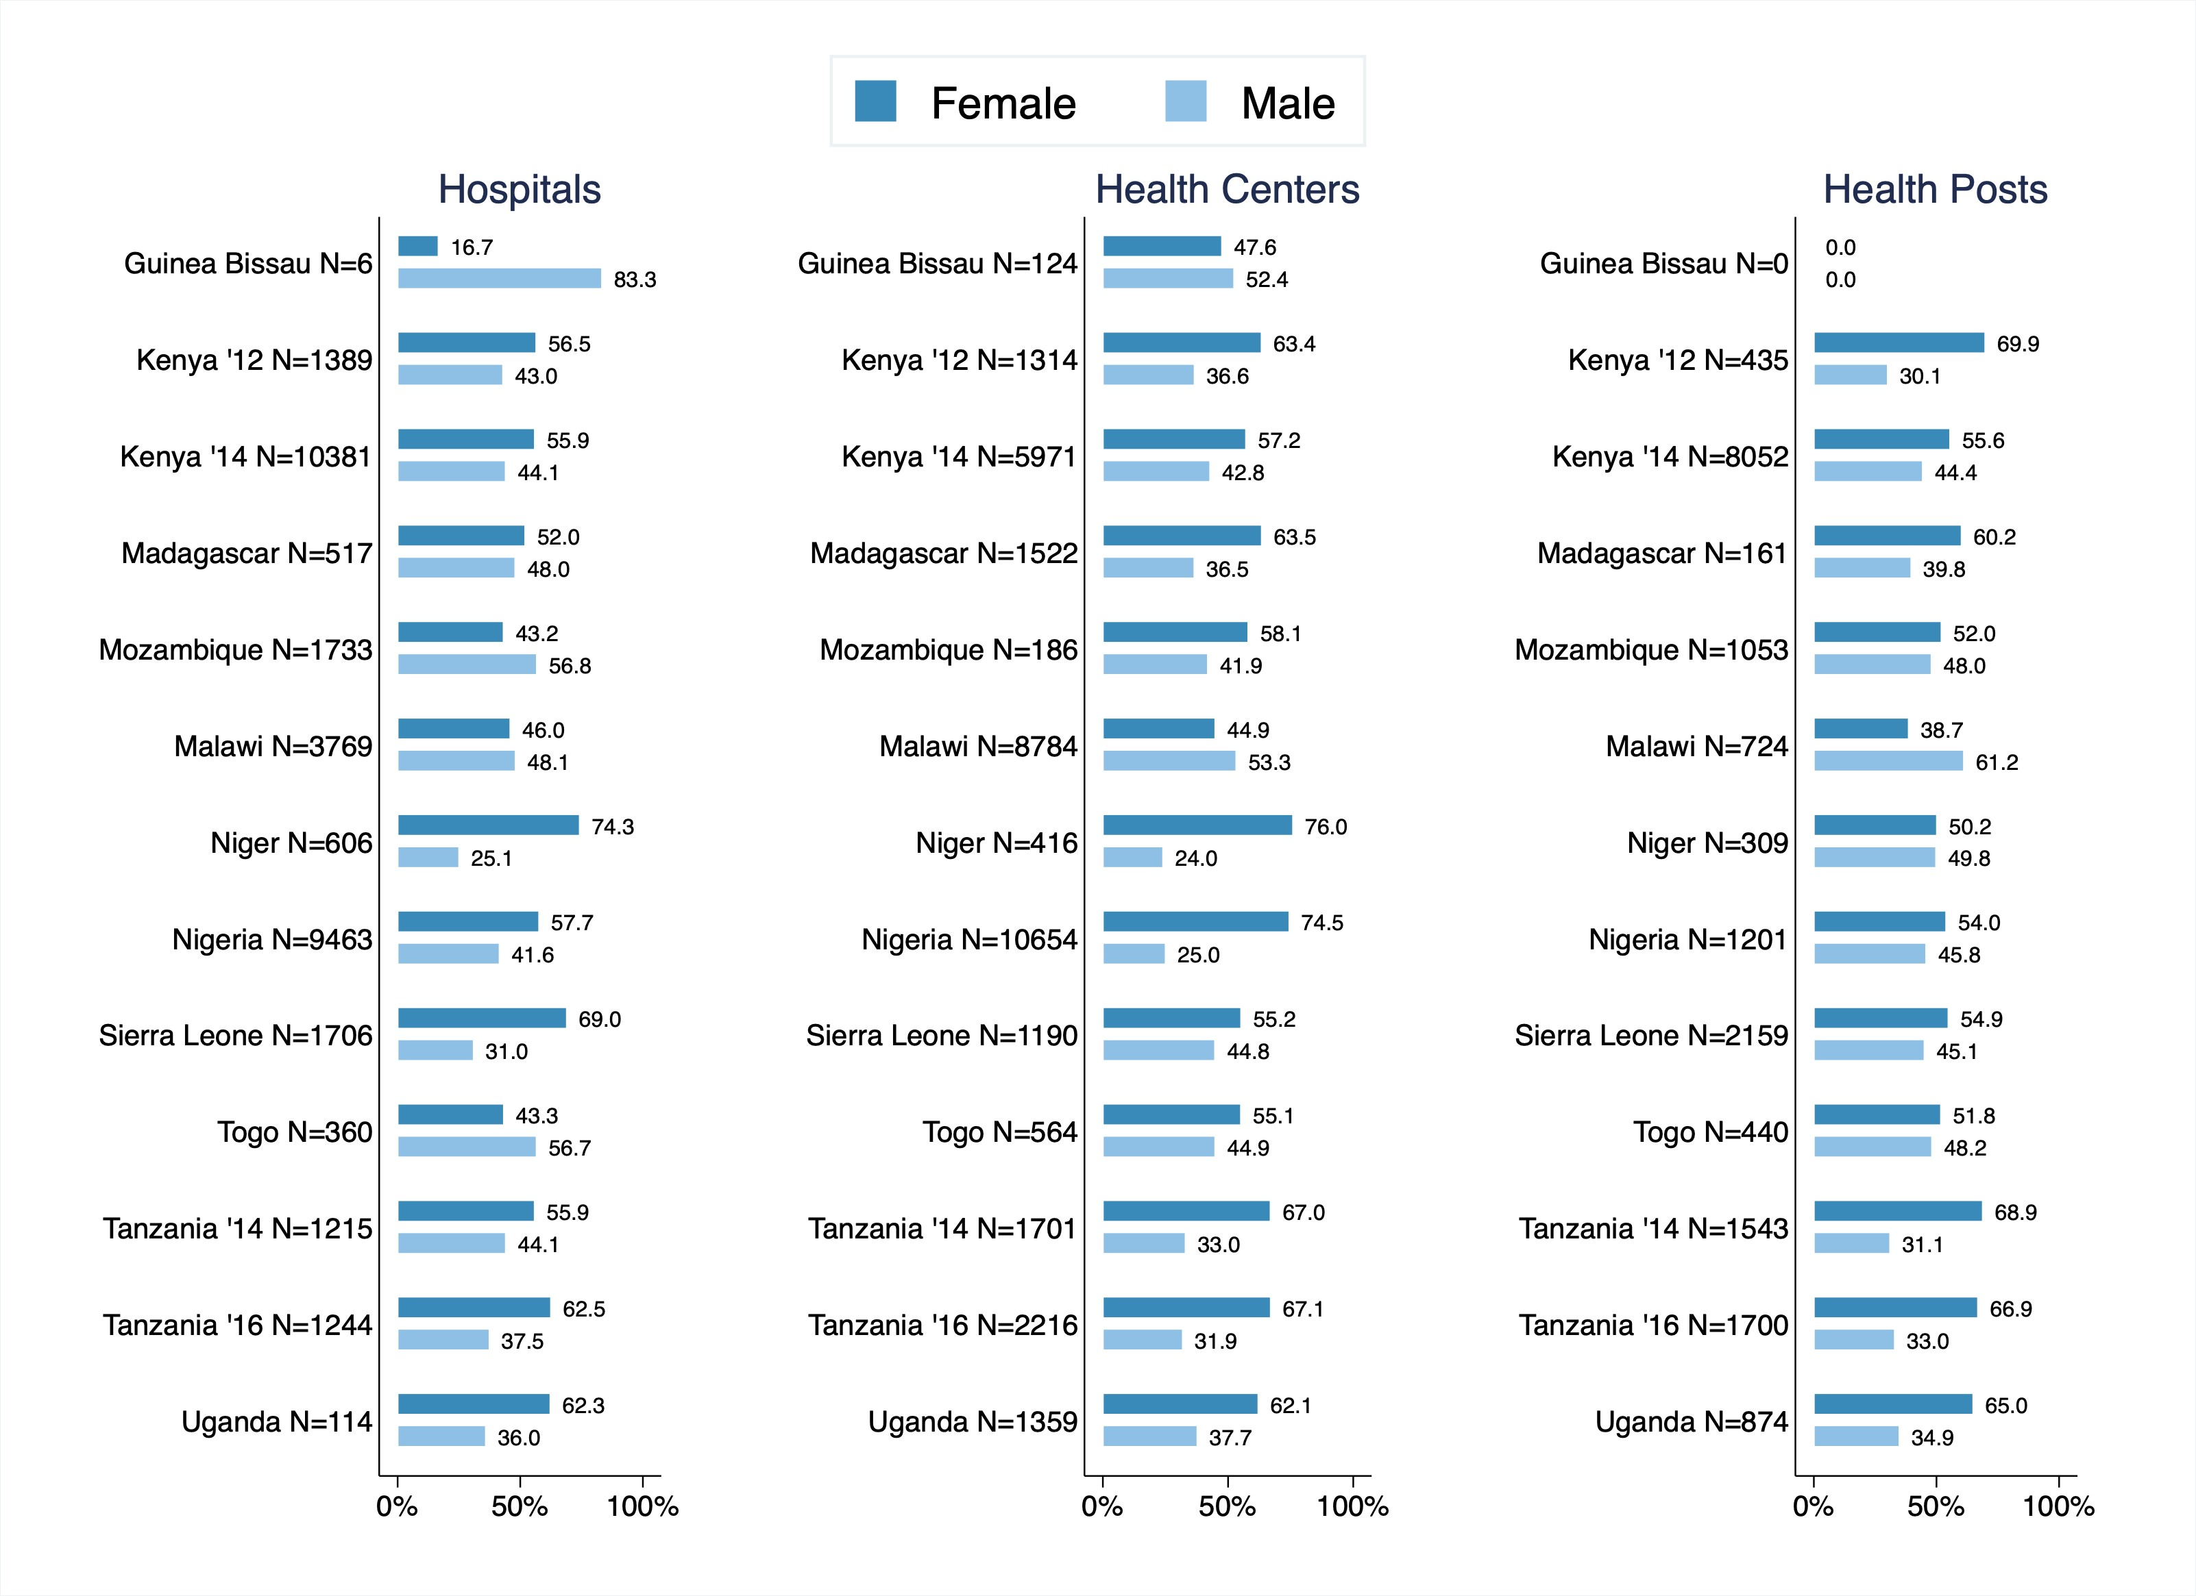

Figure 2: Age of Providers by Gender and Occupation

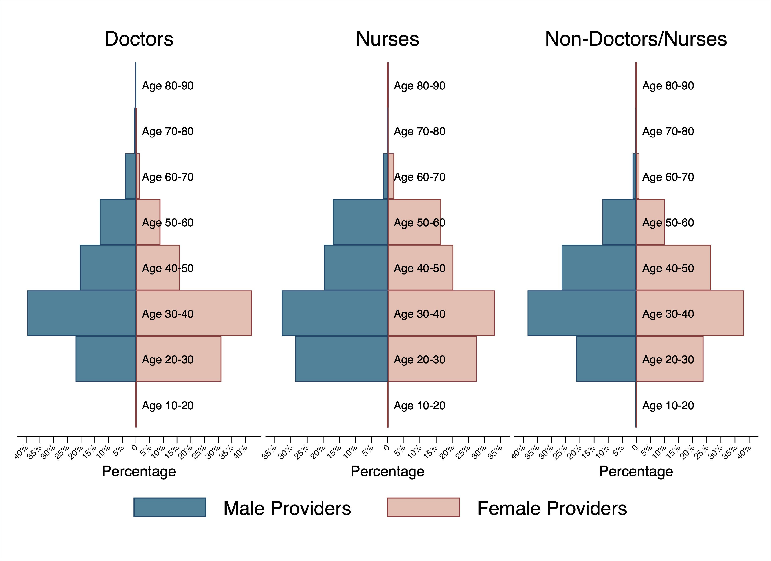

## The Availability of Medical Officers

This results subsection will discuss the availability of medical officers using the two figures below.

Figure 3: Share of Clinics that have a Medical Officer

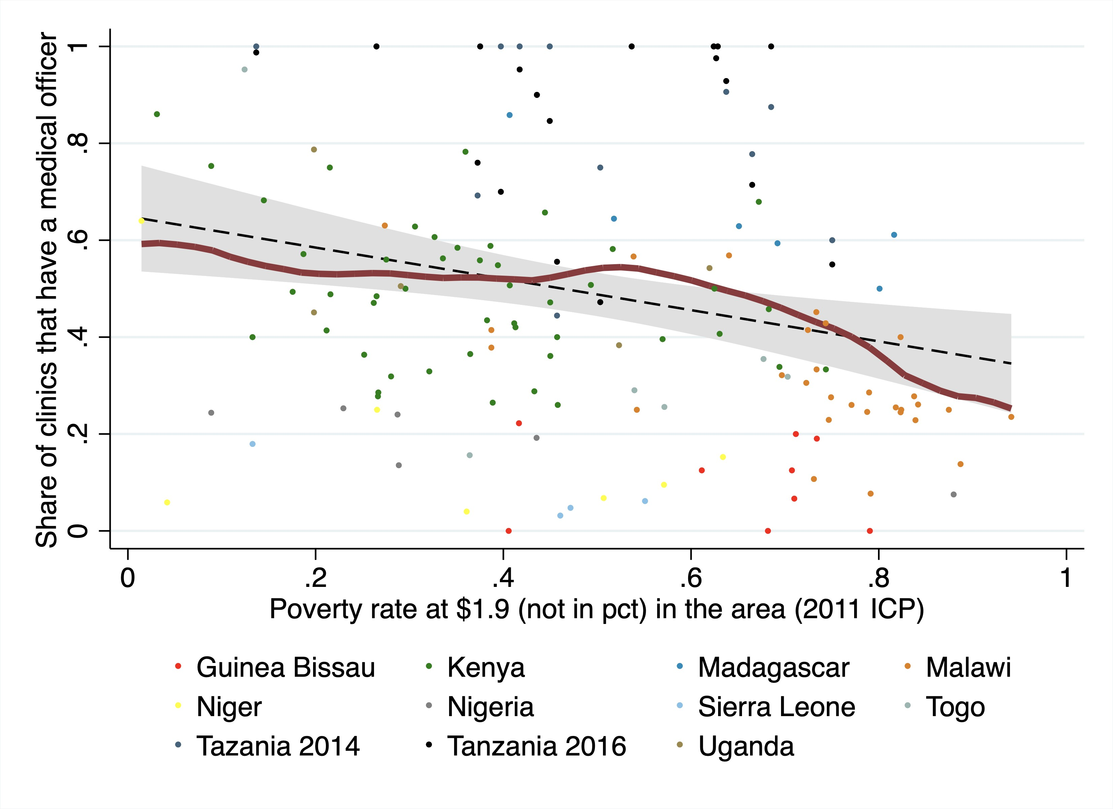

Figure 4: Share of Clinics that have a Medical Officer by Region

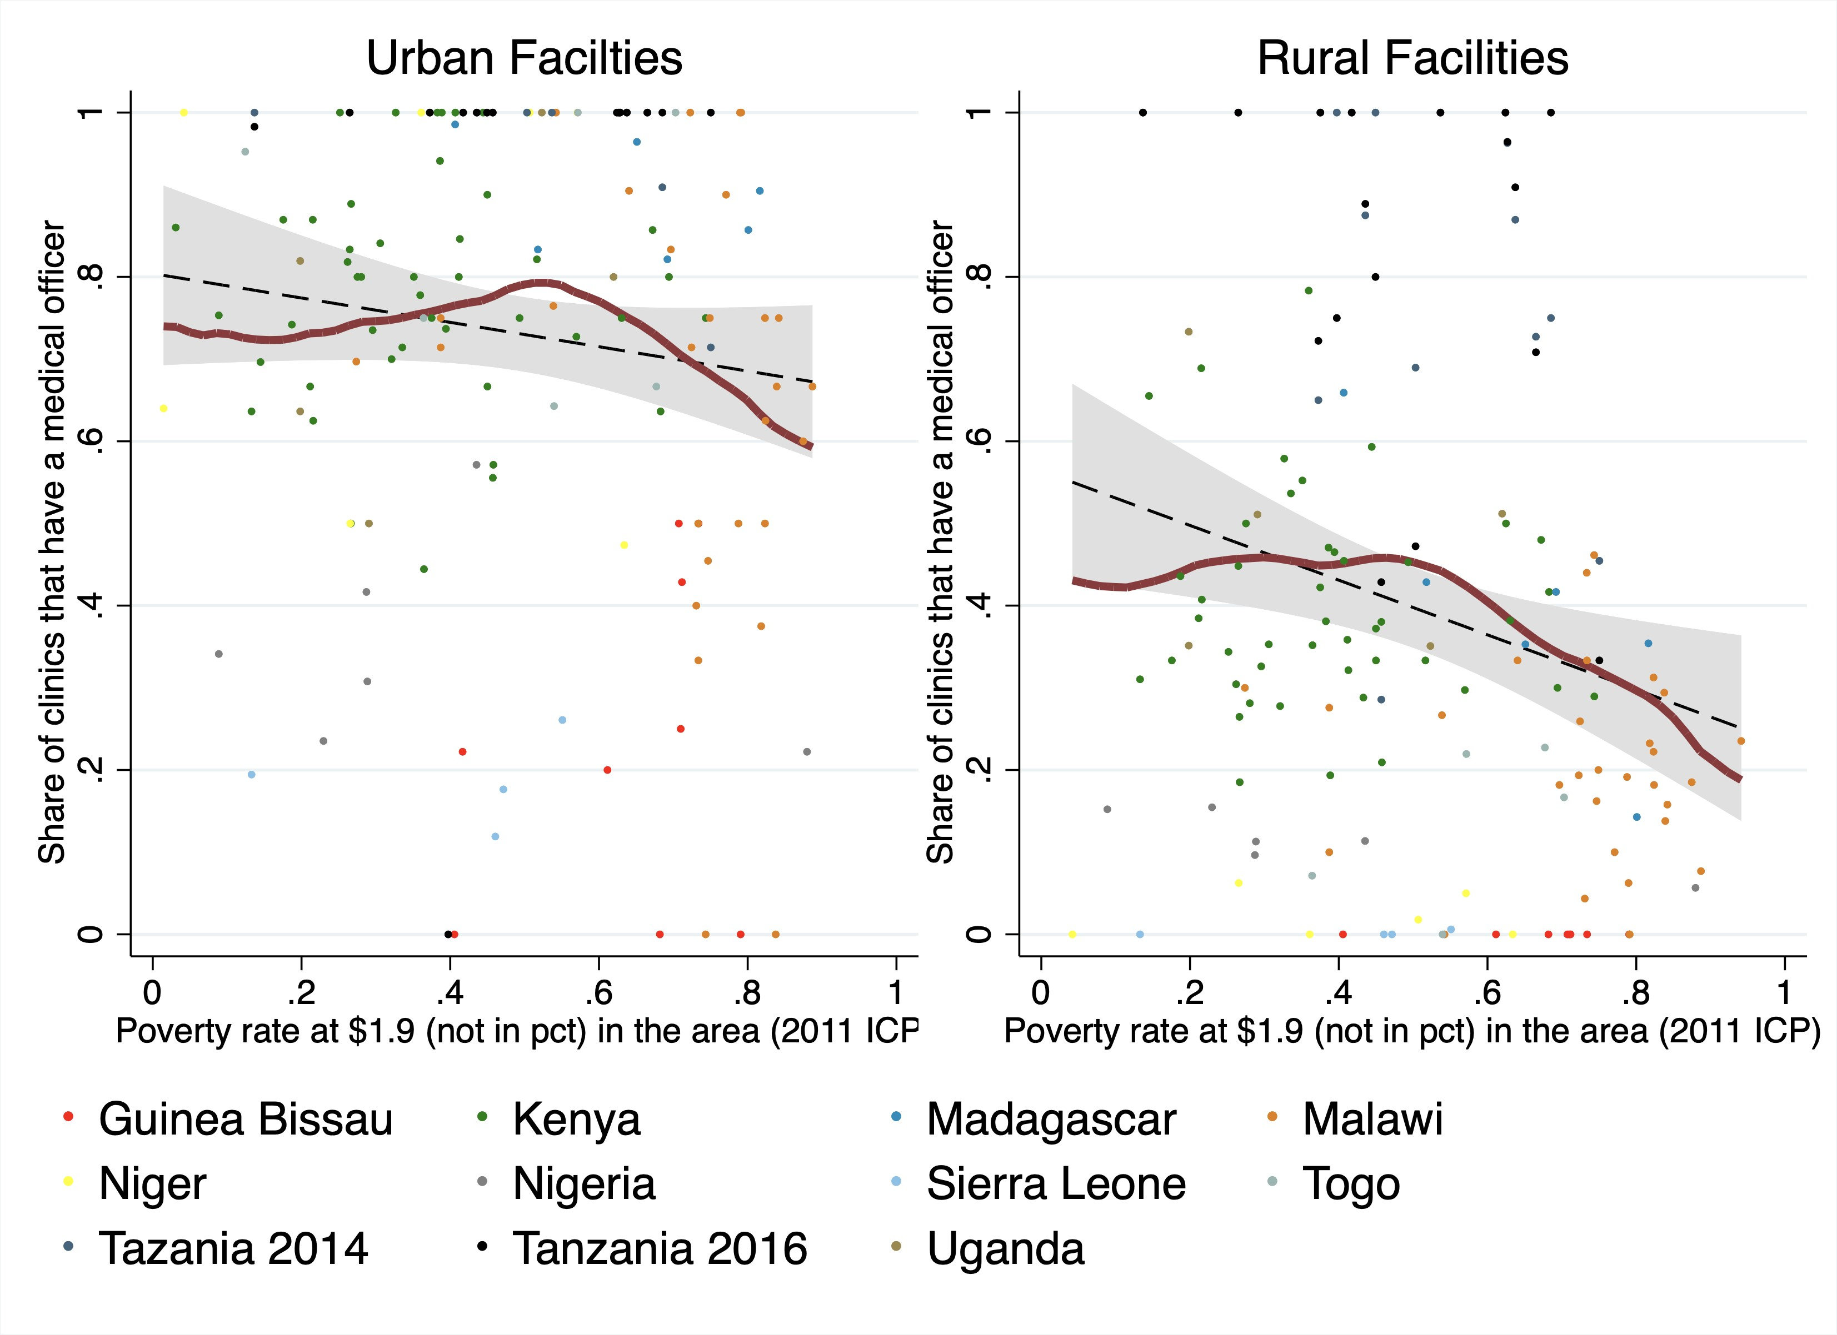

## Limitations of the Sample

This section will describe the limitations of the surveys and data.

[Bring in information from the appendices of the SDI Analytical Report]

# Discussion

In this section, we discuss the main findings of the surveys and their implications

# References

List all the references cited either numbered or unnumbered depending on the journal this paper is submitted to.